HTML Form Elements

📘 Definition
# Source: AI Source: Provided by: [Data Path: Persons Table -> ID Column: 1, Name_En Column: Motasem Essam] -> From: [ChatGPT] on [5/6/2026]
HTML forms are used to collect user input.
Forms are commonly used for:
- login pages
- registration
- search bars
- contact forms
- surveys

🧠 Main Form Elements
# Source: AI Source: Provided by: [Data Path: Persons Table -> ID Column: 1, Name_En Column: Motasem Essam] -> From: [ChatGPT] on [5/6/2026]
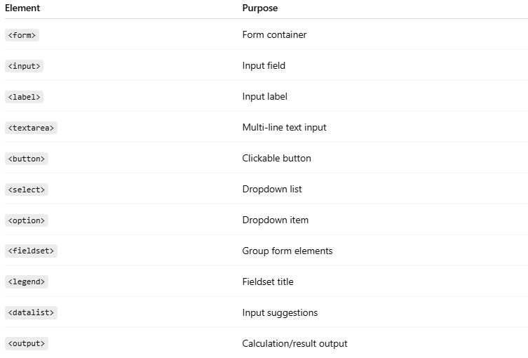
Element | Purpose
<form> | Form container
<input> | Input field
<label> | Input label
<textarea> | Multi-line text input
<button> | Clickable button
<select> | Dropdown list
<option> | Dropdown item
<fieldset> | Group form elements
<legend> | Fieldset title
<datalist> | Input suggestions
<output> | Calculation/result output

1. 📋 <form>
# Source: AI Source: Provided by: [Data Path: Persons Table -> ID Column: 1, Name_En Column: Motasem Essam] -> From: [ChatGPT] on [5/6/2026]
📖 Description
Main container for form elements.
💻 Example:
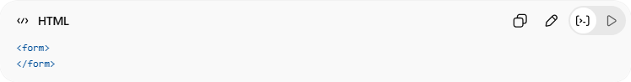
<form>
</form>
🔤 Common Attributes
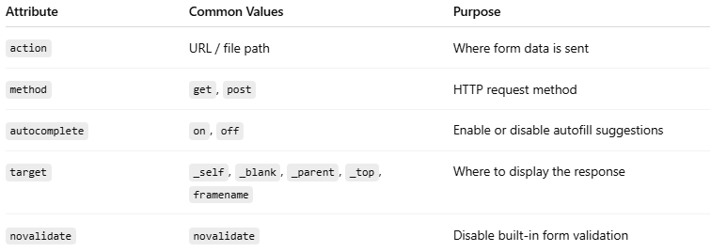
Attribute | Common Values | Purpose
action | URL / file path | Where form data is sent
method | get, post | HTTP request method
autocomplete | on, off | Enable or disable autofill suggestions
target | _self, _blank, _parent, _top, framename | Where to display the response
novalidate | novalidate | Disable built-in form validation

💻 Example:
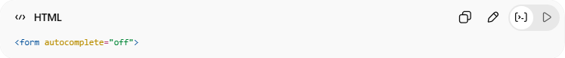
<form action="save.php"
method="post">

2. ⌨️ <input>
# Source: AI Source: Provided by: [Data Path: Persons Table -> ID Column: 1, Name_En Column: Motasem Essam] -> From: [ChatGPT] on [5/6/2026]
📖 Description
Creates input fields.
💻 Example:
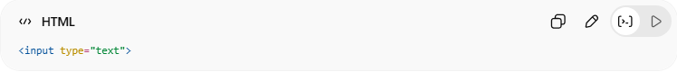
<input type="text">
🔤 Common Input Types
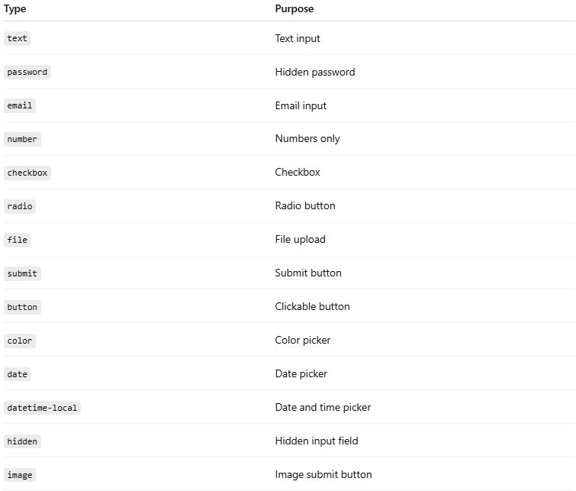
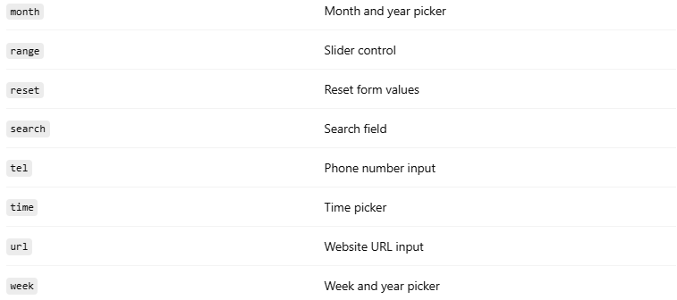

Type | Purpose
text | Text input
password | Hidden password
email | Email input
number | Numbers only
checkbox | Checkbox
radio | Radio button
file | File upload
submit | Submit button
button | Clickable button
color | Color picker
date | Date picker
datetime-local | Date and time picker
hidden | Hidden input field
image | Image submit button
month | Month and year picker
range | Slider control
reset | Reset form values
search | Search field
tel | Phone number input
time | Time picker
url | Website URL input
week | Week and year picker

3. 🏷️ <label>
# Source: AI Source: Provided by: [Data Path: Persons Table -> ID Column: 1, Name_En Column: Motasem Essam] -> From: [ChatGPT] on [5/6/2026]
📖 Description
Adds labels for form fields.
💻 Example:
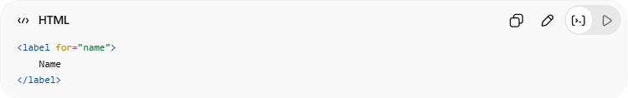
<label for="name">
Name
</label>

4. 📄 <textarea>
# Source: AI Source: Provided by: [Data Path: Persons Table -> ID Column: 1, Name_En Column: Motasem Essam] -> From: [ChatGPT] on [5/6/2026]
📖 Description
Creates multi-line text input.
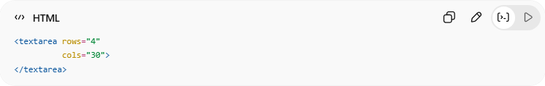
💻 Example:
<textarea rows="4"
cols="30">
</textarea>

5. 🔘 <button>
# Source: AI Source: Provided by: [Data Path: Persons Table -> ID Column: 1, Name_En Column: Motasem Essam] -> From: [ChatGPT] on [5/6/2026]
📖 Description
Creates clickable buttons.
💻 Example:
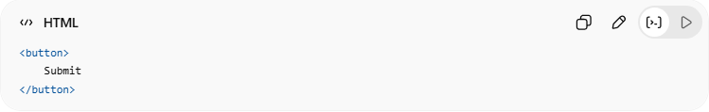
<button>
Submit
</button>

6. 📑 <select> and <option>
# Source: AI Source: Provided by: [Data Path: Persons Table -> ID Column: 1, Name_En Column: Motasem Essam] -> From: [ChatGPT] on [5/6/2026]
📖 Description
Creates dropdown lists.
💻 Example:
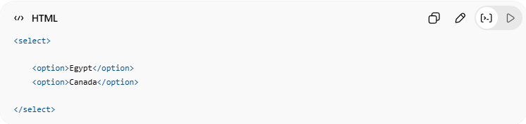
<select>
<option>Egypt</option>
<option>Canada</option>
</select>

7. 🧩 <fieldset> and <legend>
# Source: AI Source: Provided by: [Data Path: Persons Table -> ID Column: 1, Name_En Column: Motasem Essam] -> From: [ChatGPT] on [5/6/2026]
📖 Description
Groups related form fields.
💻 Example:
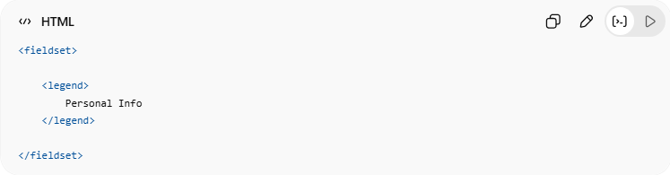
<fieldset>
<legend>
Personal Info
</legend>
</fieldset>

8. 💡 <datalist>
# Source: AI Source: Provided by: [Data Path: Persons Table -> ID Column: 1, Name_En Column: Motasem Essam] -> From: [ChatGPT] on [5/6/2026]
📖 Description
Provides autocomplete suggestions.
💻 Example:
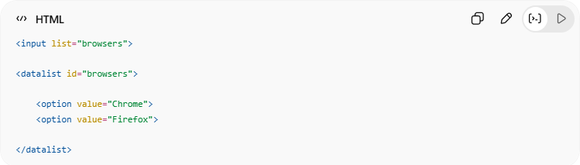
<input list="browsers">
<datalist id="browsers">
<option value="Chrome">
<option value="Firefox">
</datalist>

9. 🖥️ <output>
# Source: AI Source: Provided by: [Data Path: Persons Table -> ID Column: 1, Name_En Column: Motasem Essam] -> From: [ChatGPT] on [5/6/2026]
📖 Description
Displays calculation or script results.
💻 Example:
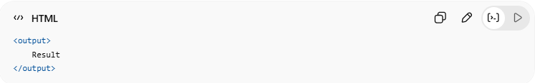
<output>
Result
</output>

💻 Example

Full Example
# Source: AI Source: Provided by: [Data Path: Persons Table -> ID Column: 1, Name_En Column: Motasem Essam] -> From: [ChatGPT] on [5/6/2026]
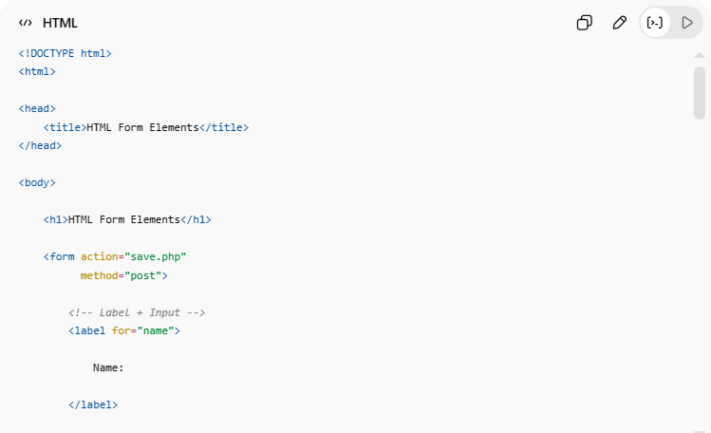
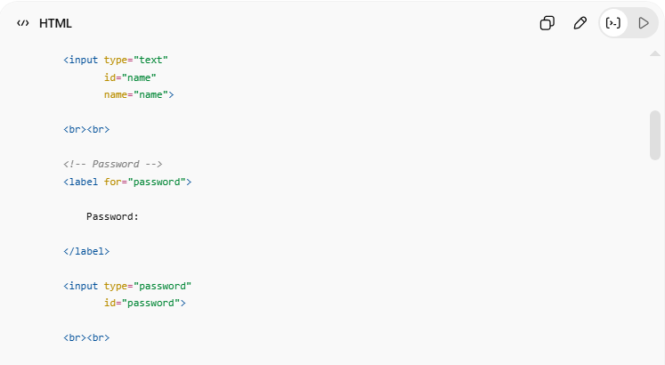
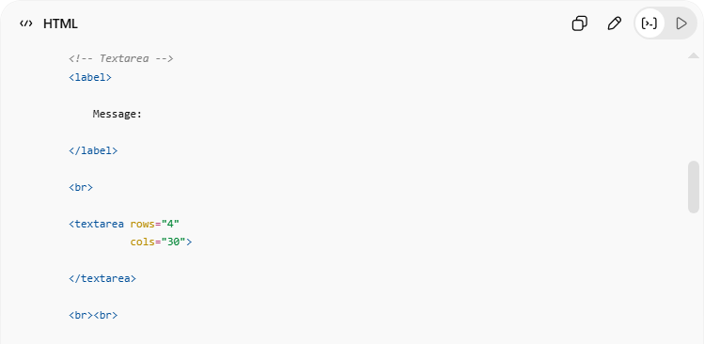
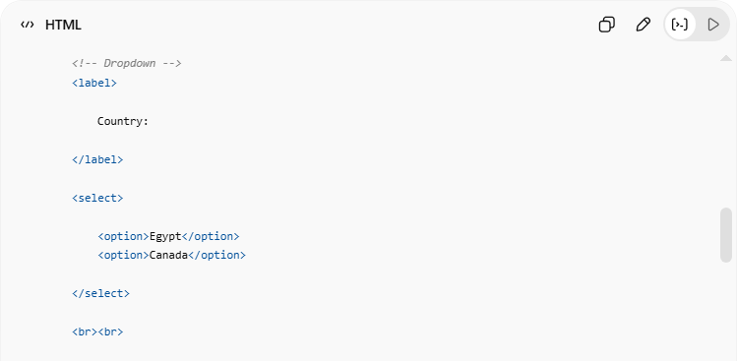
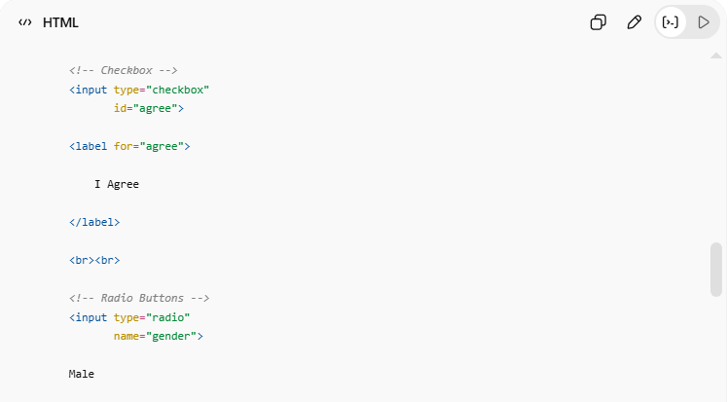
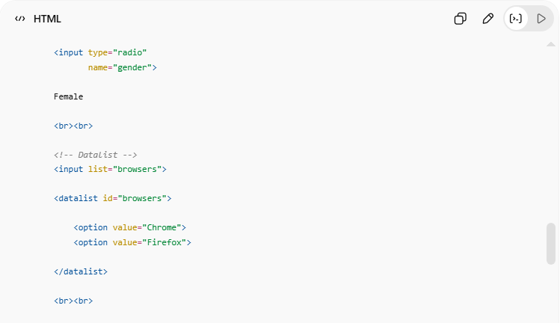
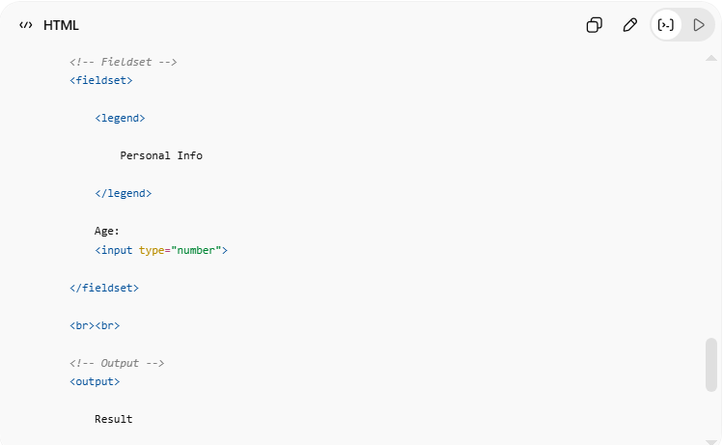
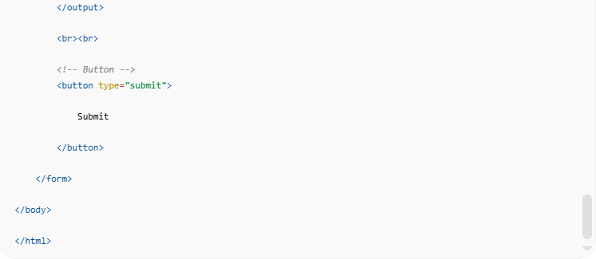
<!DOCTYPE html>
<html>
<head>
<title>HTML Form Elements</title>
</head>
<body>
<h1>HTML Form Elements</h1>
<form action="save.php"
method="post">
<!-- Label + Input -->
<label for="name">
Name:
</label>
<input type="text"
id="name"
name="name">
<br><br>
<!-- Password -->
<label for="password">
Password:
</label>
<input type="password"
id="password">
<br><br>
<!-- Textarea -->
<label>
Message:
</label>
<br>
<textarea rows="4"
cols="30">
</textarea>
<br><br>
<!-- Dropdown -->
<label>
Country:
</label>
<select>
<option>Egypt</option>
<option>Canada</option>
</select>
<br><br>
<!-- Checkbox -->
<input type="checkbox"
id="agree">
<label for="agree">
I Agree
</label>
<br><br>
<!-- Radio Buttons -->
<input type="radio"
name="gender">
Male
<input type="radio"
name="gender">
Female
<br><br>
<!-- Datalist -->
<input list="browsers">
<datalist id="browsers">
<option value="Chrome">
<option value="Firefox">
</datalist>
<br><br>
<!-- Fieldset -->
<fieldset>
<legend>
Personal Info
</legend>
Age:
<input type="number">
</fieldset>
<br><br>
<!-- Output -->
<output>
Result
</output>
<br><br>
<!-- Button -->
<button type="submit">
Submit
</button>
</form>
</body>
</html>

Real Example
# Source: ScreenShot Source: Provided by: [Persons Table -> ID Column: 1, Name_En Column: Motasem Essam] -> Tool: [Automation Table -> ID Column: 16, Name_En Column: Screen Capture] -> From [Operating System: Windows] on [5/6/2026]
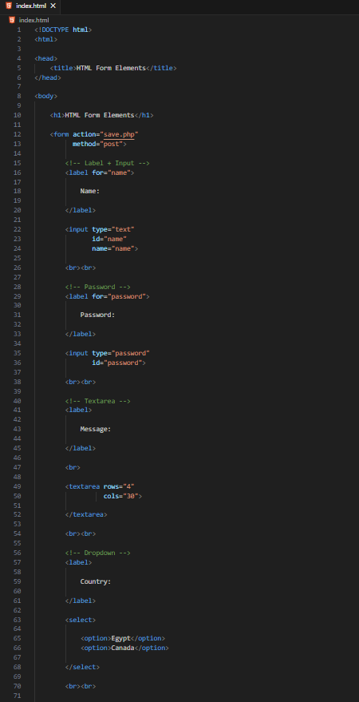
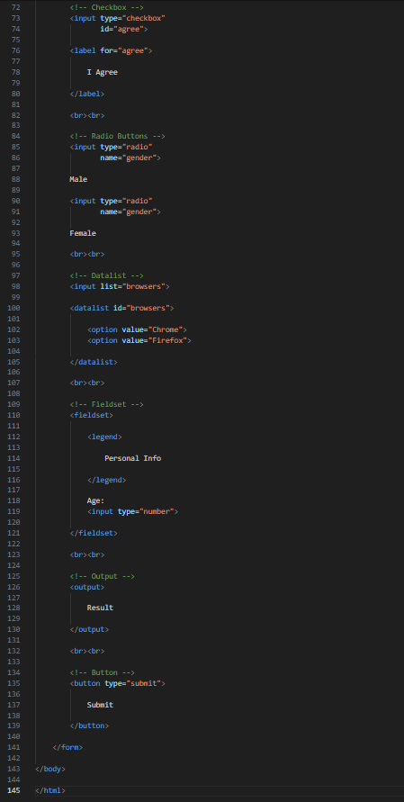
<!DOCTYPE html>
<html>

<head>
<title>HTML Form Elements</title>
</head>

<body>

<h1>HTML Form Elements</h1>

<form action="save.php"
method="post">

<!-- Label + Input -->
<label for="name">

Name:

</label>

<input type="text"
id="name"
name="name">

<br><br>

<!-- Password -->
<label for="password">

Password:

</label>

<input type="password"
id="password">

<br><br>

<!-- Textarea -->
<label>

Message:

</label>

<br>

<textarea rows="4"
cols="30">

</textarea>

<br><br>

<!-- Dropdown -->
<label>

Country:

</label>

<select>

<option>Egypt</option>
<option>Canada</option>

</select>

<br><br>

<!-- Checkbox -->
<input type="checkbox"
id="agree">

<label for="agree">

I Agree

</label>

<br><br>

<!-- Radio Buttons -->
<input type="radio"
name="gender">

Male

<input type="radio"
name="gender">

Female

<br><br>

<!-- Datalist -->
<input list="browsers">

<datalist id="browsers">

<option value="Chrome">
<option value="Firefox">

</datalist>

<br><br>

<!-- Fieldset -->
<fieldset>

<legend>

Personal Info

</legend>

Age:
<input type="number">

</fieldset>

<br><br>

<!-- Output -->
<output>

Result

</output>

<br><br>

<!-- Button -->
<button type="submit">

Submit

</button>

</form>

</body>

</html>

# Source: GIF Source: Provided by: [Persons Table -> ID Column: 1, Name_En Column: Motasem Essam] -> Tool: [Automation Table -> ID Column: 17, Name_En Column: GIF Recorder] -> From [Operating System: Windows] on [5/6/2026]


🧪 What You Can Test
# Source: AI Source: Provided by: [Data Path: Persons Table -> ID Column: 1, Name_En Column: Motasem Essam] -> From: [ChatGPT] on [5/6/2026]
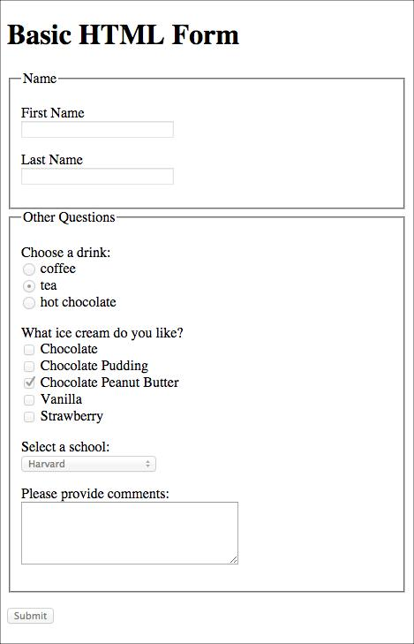
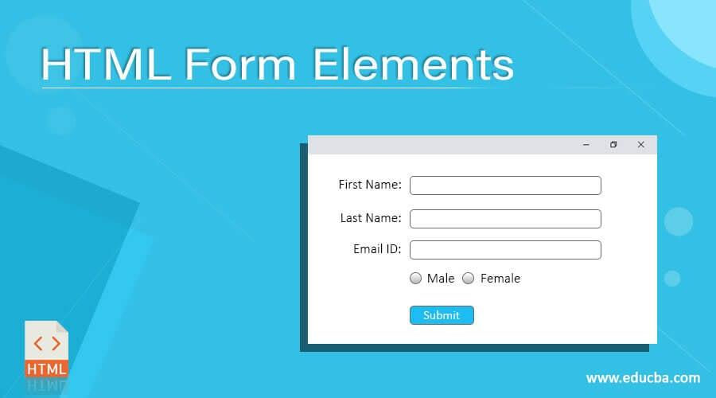
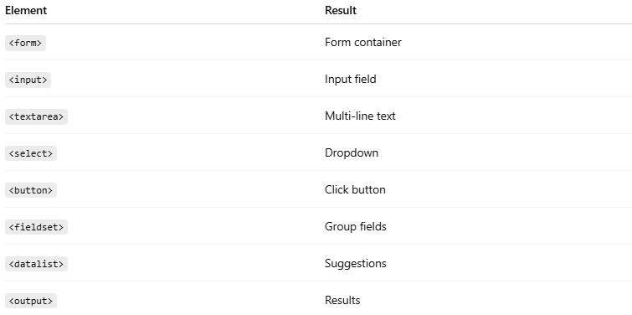
Element | Result
<form> | Form container
<input> | Input field
<textarea> | Multi-line text
<select> | Dropdown
<button> | Click button
<fieldset> | Group fields
<datalist> | Suggestions
<output> | Results

📝HTML Form Attributes

Action
# Source: AI Source: Provided by: [Data Path: Persons Table -> ID Column: 1, Name_En Column: Motasem Essam] -> From: [ChatGPT] on [5/6/2026]
📖 Description
Specifies where the form data will be sent after submission.
🔤 Common Values
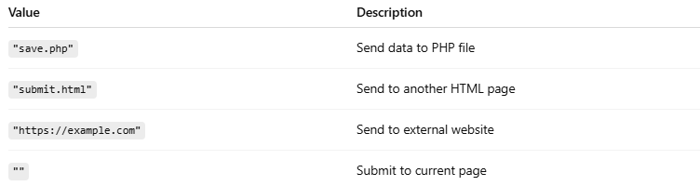
Value | Description
"save.php" | Send data to PHP file
"submit.html" | Send to another HTML page
"https://example.com" | Send to external website
"" | Submit to current page

💻 Example:
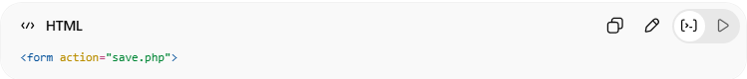
<form action="save.php">

Method
# Source: AI Source: Provided by: [Data Path: Persons Table -> ID Column: 1, Name_En Column: Motasem Essam] -> From: [ChatGPT] on [5/6/2026]
📖 Description
Defines how form data is sent to the server.
🔤 Values
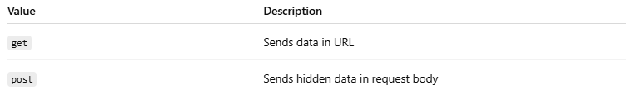
Value | Description
get | Sends data in URL
post | Sends hidden data in request body

💻 Example — GET
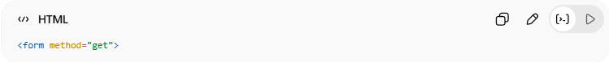
<form method="get">
👉 URL example:
page.php?name=Ali

💻 Example — POST
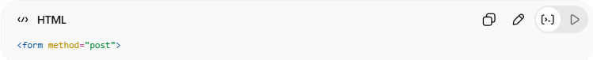
<form method="post">
👉 Data hidden from URL

⚠️ GET vs POST
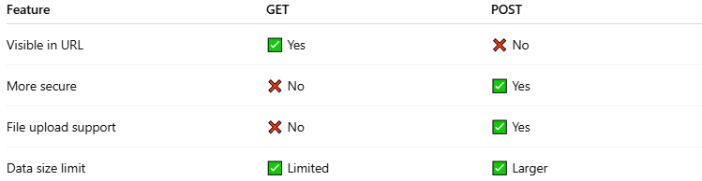
Feature | GET | POST
Visible in URL | ✅ Yes | ❌ No
More secure | ❌ No | ✅ Yes
File upload support | ❌ No | ✅ Yes
Data size limit | ✅ Limited | ✅ Larger

Autocomplete
# Source: AI Source: Provided by: [Data Path: Persons Table -> ID Column: 1, Name_En Column: Motasem Essam] -> From: [ChatGPT] on [5/6/2026]
📖 Description
Controls browser autofill suggestions.
🔤 Values
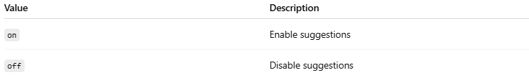
Value | Description
on | Enable suggestions
off | Disable suggestions

💻 Example — ON
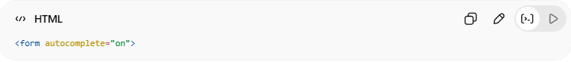
<form autocomplete="on">
👉 Browser remembers input values

💻 Example — OFF

<form autocomplete="off">
👉 Browser does not save suggestions

Target
# Source: AI Source: Provided by: [Data Path: Persons Table -> ID Column: 1, Name_En Column: Motasem Essam] -> From: [ChatGPT] on [5/6/2026]
📖 Description
The target attribute specifies where to open the response after submitting the form.
🔤 Common Values
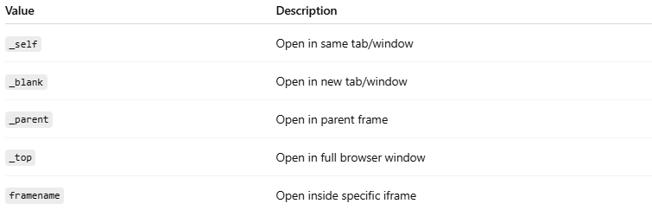
Value | Description
_self | Open in same tab/window
_blank | Open in new tab/window
_parent | Open in parent frame
_top | Open in full browser window
framename | Open inside specific iframe

💻 Example:
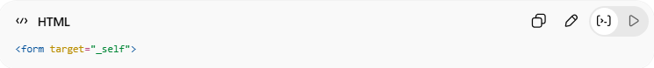
<form target="_self">

Novalidate
# Source: AI Source: Provided by: [Data Path: Persons Table -> ID Column: 1, Name_En Column: Motasem Essam] -> From: [ChatGPT] on [5/6/2026]
📖 Description
Disables built-in HTML form validation.

💻 Example
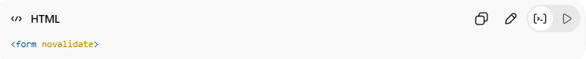
<form novalidate>
👉 Form submits even if inputs are invalid

💻 Example Without Validation
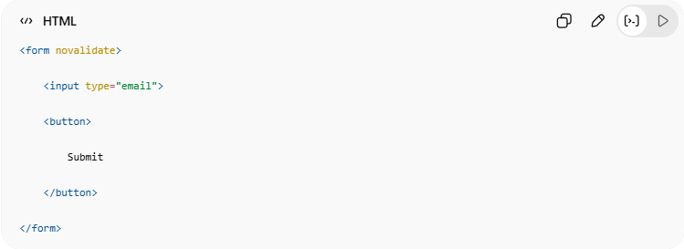
<form novalidate>
<input type="email">
<button>
Submit
</button>
</form>
👉 Invalid email can still submit

📑 HTML select and option Attributes

Value
# Source: AI Source: Provided by: [Data Path: Persons Table -> ID Column: 1, Name_En Column: Motasem Essam] -> From: [ChatGPT] on [5/6/2026]
📖 Description
The value attribute defines the data sent when the form is submitted.

💻 Example:
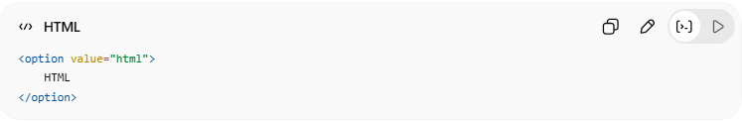
<option value="html">
HTML
</option>
👉 User sees HTML
👉 Form sends html

Visible Values
# Source: AI Source: Provided by: [Data Path: Persons Table -> ID Column: 1, Name_En Column: Motasem Essam] -> From: [ChatGPT] on [5/6/2026]
📖 Description
The size attribute controls how many options are visible.
👉 Turns dropdown into a visible list.

💻 Example:
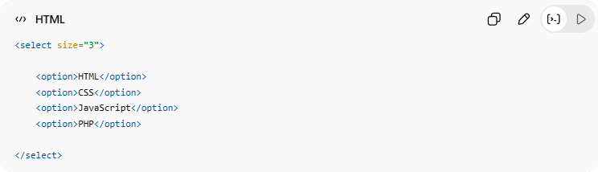
<select size="3">
<option>HTML</option>
<option>CSS</option>
<option>JavaScript</option>
<option>PHP</option>
</select>
👉 Shows 3 visible items

Allow Multiple Selections
# Source: AI Source: Provided by: [Data Path: Persons Table -> ID Column: 1, Name_En Column: Motasem Essam] -> From: [ChatGPT] on [5/6/2026]
📖 Description
The multiple attribute allows selecting multiple options.
👉 Usually used with:
- Ctrl
- Shift
keys.

💻 Example:
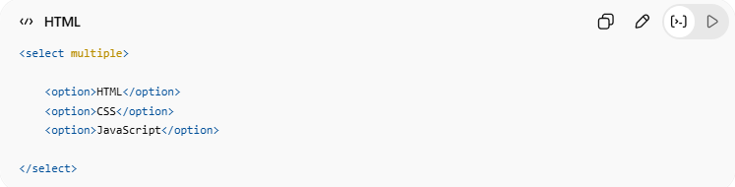
<select multiple>
<option>HTML</option>
<option>CSS</option>
<option>JavaScript</option>
</select>
👉 User can select multiple items

🧩 HTML Input Attributes
# Source: AI Source: Provided by: [Data Path: Persons Table -> ID Column: 1, Name_En Column: Motasem Essam] -> From: [ChatGPT] on [5/6/2026]
HTML input attributes provide extra behavior and control for form elements.
They can:
- validate input
- limit values
- improve usability
- customize form submission

🧠 Common Input Attributes
# Source: AI Source: Provided by: [Data Path: Persons Table -> ID Column: 1, Name_En Column: Motasem Essam] -> From: [ChatGPT] on [5/6/2026]
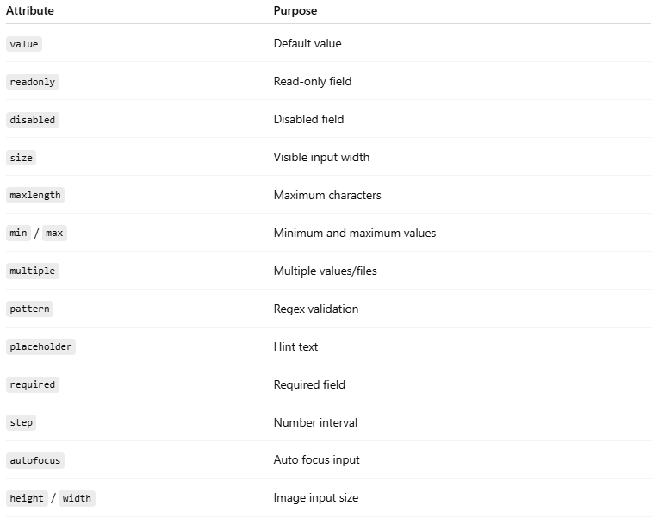
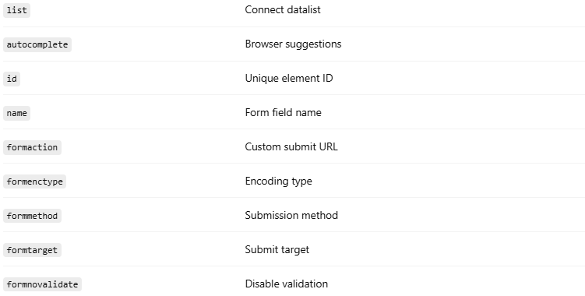
Attribute | Purpose
value | Default value
readonly | Read-only field
disabled | Disabled field
size | Visible input width
maxlength | Maximum characters
min / max | Minimum and maximum values
multiple | Multiple values/files
pattern | Regex validation
placeholder | Hint text
required | Required field
step | Number interval
autofocus | Auto focus input
height / width | Image input size
list | Connect datalist
autocomplete | Browser suggestions
id | Unique element ID
name | Form field name
formaction | Custom submit URL
formenctype | Encoding type
formmethod | Submission method
formtarget | Submit target
formnovalidate | Disable validation

1. 🔤 value
# Source: AI Source: Provided by: [Data Path: Persons Table -> ID Column: 1, Name_En Column: Motasem Essam] -> From: [ChatGPT] on [5/6/2026]
📖 Description
Sets the default input value.
💻 Example:
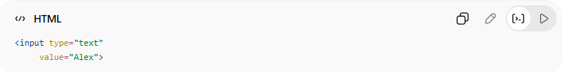
<input type="text"
value="Alex">

2. 🔒 readonly
# Source: AI Source: Provided by: [Data Path: Persons Table -> ID Column: 1, Name_En Column: Motasem Essam] -> From: [ChatGPT] on [5/6/2026]
📖 Description
User can view but cannot edit.
💻 Example:
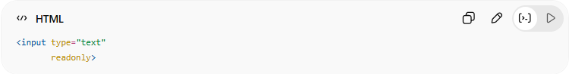
<input type="text"
readonly>

3. ❌ disabled
# Source: AI Source: Provided by: [Data Path: Persons Table -> ID Column: 1, Name_En Column: Motasem Essam] -> From: [ChatGPT] on [5/6/2026]
📖 Description
Disables the input completely.
💻 Example:
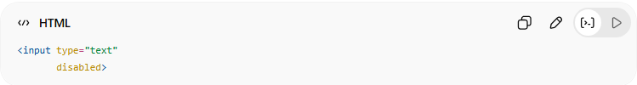
<input type="text"
disabled>

4. 📏 size
# Source: AI Source: Provided by: [Data Path: Persons Table -> ID Column: 1, Name_En Column: Motasem Essam] -> From: [ChatGPT] on [5/6/2026]
📖 Description
Controls visible input width.
💻 Example:
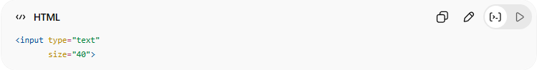
<input type="text"
size="40">

5. 🔢 maxlength
# Source: AI Source: Provided by: [Data Path: Persons Table -> ID Column: 1, Name_En Column: Motasem Essam] -> From: [ChatGPT] on [5/6/2026]
📖 Description
Limits maximum characters.
💻 Example:
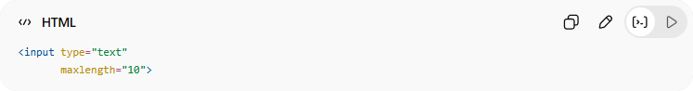
<input type="text"
maxlength="10">

6. 📉 min and max
# Source: AI Source: Provided by: [Data Path: Persons Table -> ID Column: 1, Name_En Column: Motasem Essam] -> From: [ChatGPT] on [5/6/2026]
📖 Description
Defines allowed value range.
💻 Example:
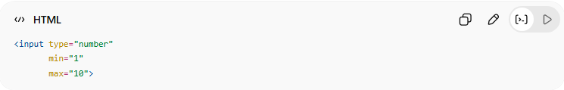
<input type="number"
min="1"
max="10">

7. 📚 multiple
# Source: AI Source: Provided by: [Data Path: Persons Table -> ID Column: 1, Name_En Column: Motasem Essam] -> From: [ChatGPT] on [5/6/2026]
📖 Description
Allows selecting multiple values/files.
💻 Example:
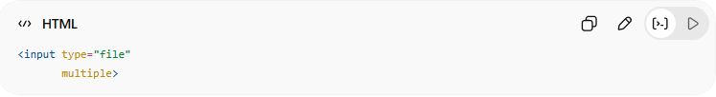
<input type="file"
multiple>

8. 🧪 pattern
# Source: AI Source: Provided by: [Data Path: Persons Table -> ID Column: 1, Name_En Column: Motasem Essam] -> From: [ChatGPT] on [5/6/2026]
📖 Description
Uses regex validation.
💻 Example:
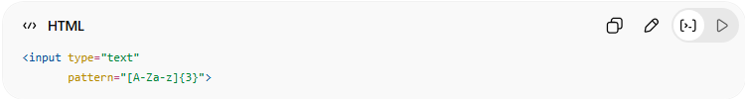
<input type="text"
pattern="[A-Za-z]{3}">
👉 Exactly 3 letters

9. 💡 placeholder
# Source: AI Source: Provided by: [Data Path: Persons Table -> ID Column: 1, Name_En Column: Motasem Essam] -> From: [ChatGPT] on [5/6/2026]
📖 Description
Shows hint text inside input.
💻 Example:
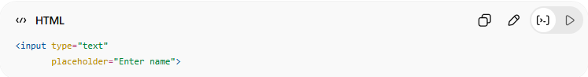
<input type="text"
placeholder="Enter name">

10. ✅ required
# Source: AI Source: Provided by: [Data Path: Persons Table -> ID Column: 1, Name_En Column: Motasem Essam] -> From: [ChatGPT] on [5/6/2026]
📖 Description
Field must be filled before submit.
💻 Example:
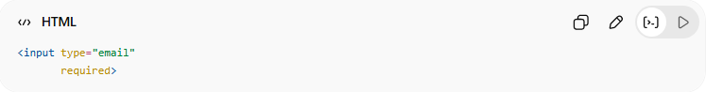
<input type="email"
required>

11. 🎚️ step
# Source: AI Source: Provided by: [Data Path: Persons Table -> ID Column: 1, Name_En Column: Motasem Essam] -> From: [ChatGPT] on [5/6/2026]
📖 Description
Controls number increments.
💻 Example:
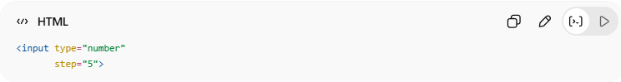
<input type="number"
step="5">

12. 🎯 autofocus
# Source: AI Source: Provided by: [Data Path: Persons Table -> ID Column: 1, Name_En Column: Motasem Essam] -> From: [ChatGPT] on [5/6/2026]
📖 Description
Automatically focuses the input when page loads.
💻 Example:
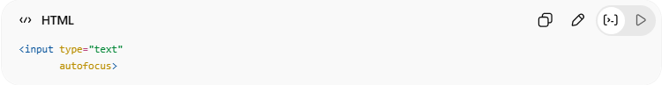
<input type="text"
autofocus>

13. 📐 height and width
# Source: AI Source: Provided by: [Data Path: Persons Table -> ID Column: 1, Name_En Column: Motasem Essam] -> From: [ChatGPT] on [5/6/2026]
📖 Description
Controls image input size.
💻 Example:
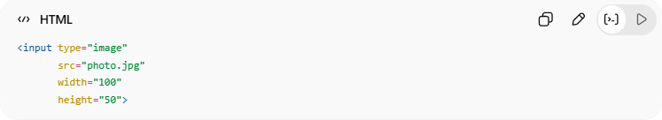
<input type="image"
src="photo.jpg"
width="100"
height="50">

14. 📋 list
# Source: AI Source: Provided by: [Data Path: Persons Table -> ID Column: 1, Name_En Column: Motasem Essam] -> From: [ChatGPT] on [5/6/2026]
📖 Description
Connects input to <datalist>.
💻 Example:
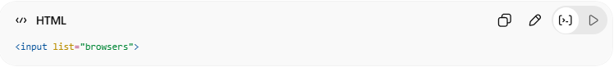
<input list="browsers">

15. 🔄 autocomplete
📖 Description
Enables/disables browser suggestions.
💻 Example:
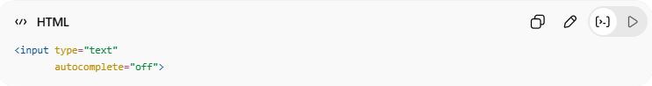
<input type="text"
autocomplete="off">

16. 🆔 id and name
# Source: AI Source: Provided by: [Data Path: Persons Table -> ID Column: 1, Name_En Column: Motasem Essam] -> From: [ChatGPT] on [5/6/2026]
📖 Description
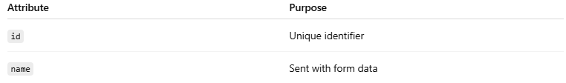
Attribute | Purpose
id | Unique identifier
name | Sent with form data
💻 Example:
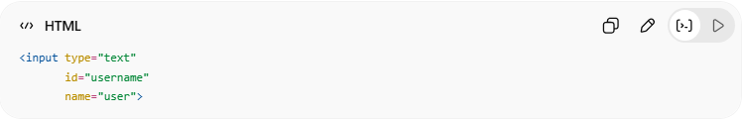
<input type="text"
id="username"
name="user">

17. 🌍 formaction
# Source: AI Source: Provided by: [Data Path: Persons Table -> ID Column: 1, Name_En Column: Motasem Essam] -> From: [ChatGPT] on [5/6/2026]
📖 Description
Changes submit URL for a button.
💻 Example:
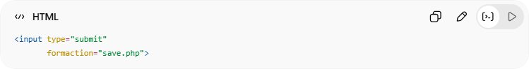
<input type="submit"
formaction="save.php">

18. 📦 formenctype
# Source: AI Source: Provided by: [Data Path: Persons Table -> ID Column: 1, Name_En Column: Motasem Essam] -> From: [ChatGPT] on [5/6/2026]
📖 Description
Controls form data encoding.
💻 Example:
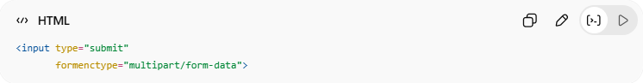
<input type="submit"
formenctype="multipart/form-data">

19. 📮 formmethod
# Source: AI Source: Provided by: [Data Path: Persons Table -> ID Column: 1, Name_En Column: Motasem Essam] -> From: [ChatGPT] on [5/6/2026]
📖 Description
Sets HTTP method.
💻 Example:
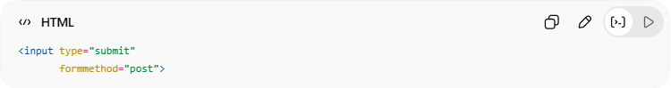
<input type="submit"
formmethod="post">

20. 🎯 formtarget
# Source: AI Source: Provided by: [Data Path: Persons Table -> ID Column: 1, Name_En Column: Motasem Essam] -> From: [ChatGPT] on [5/6/2026]
📖 Description
Controls where response opens.
💻 Example:
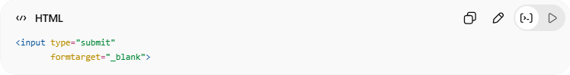
<input type="submit"
formtarget="_blank">

21. 🚫 formnovalidate
# Source: AI Source: Provided by: [Data Path: Persons Table -> ID Column: 1, Name_En Column: Motasem Essam] -> From: [ChatGPT] on [5/6/2026]
📖 Description
Disables form validation.
💻 Example:
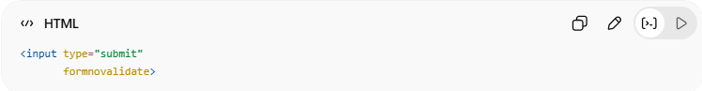
<input type="submit"
formnovalidate>

🧪 What You Can Test
# Source: AI Source: Provided by: [Data Path: Persons Table -> ID Column: 1, Name_En Column: Motasem Essam] -> From: [ChatGPT] on [5/6/2026]
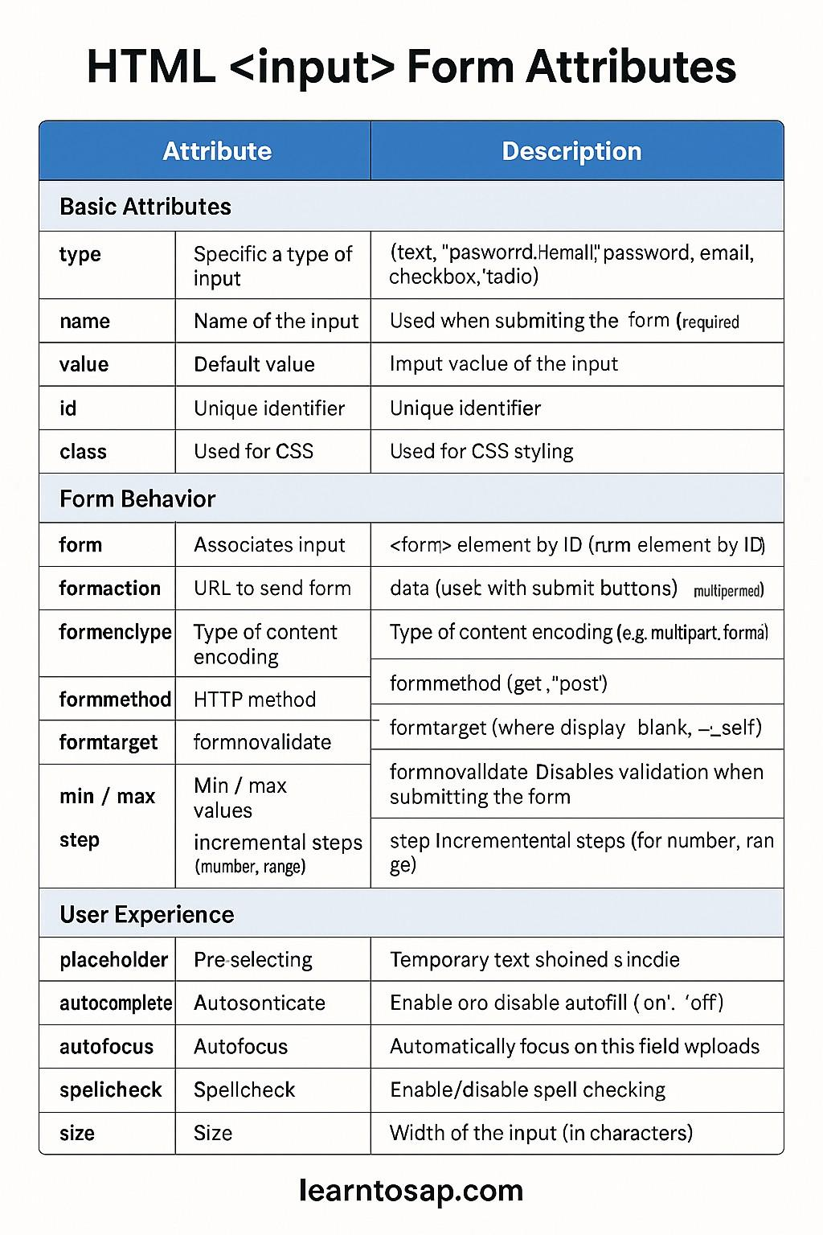
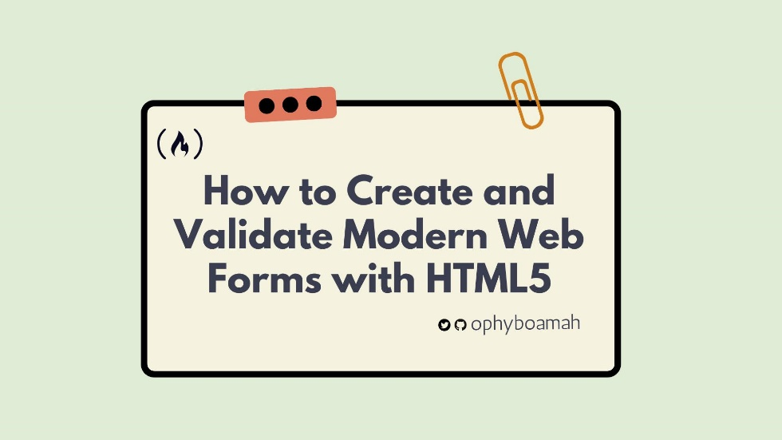
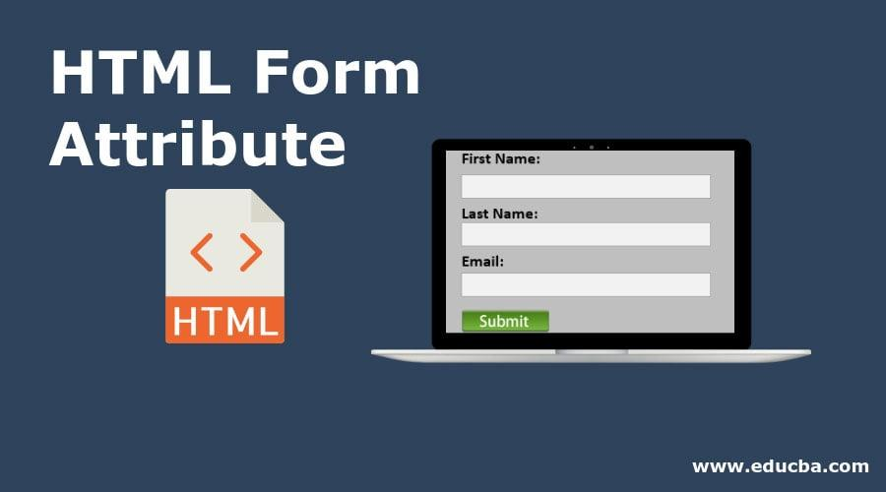
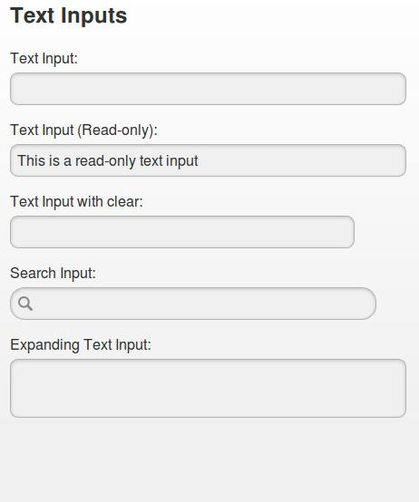
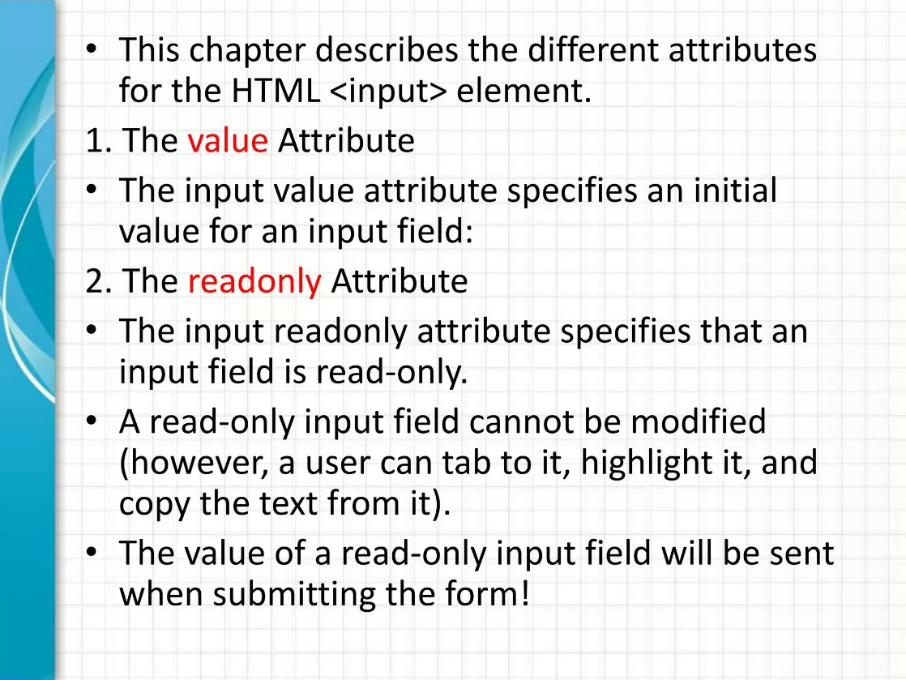
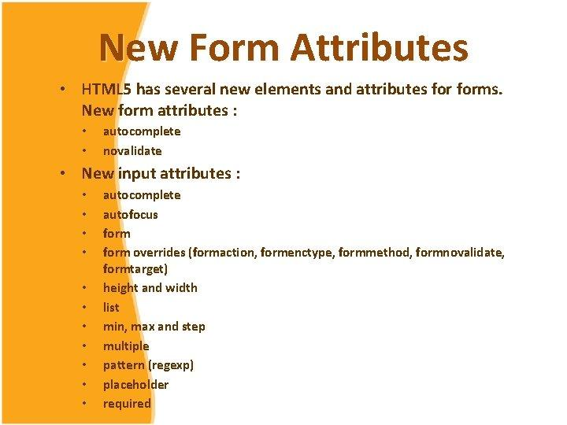
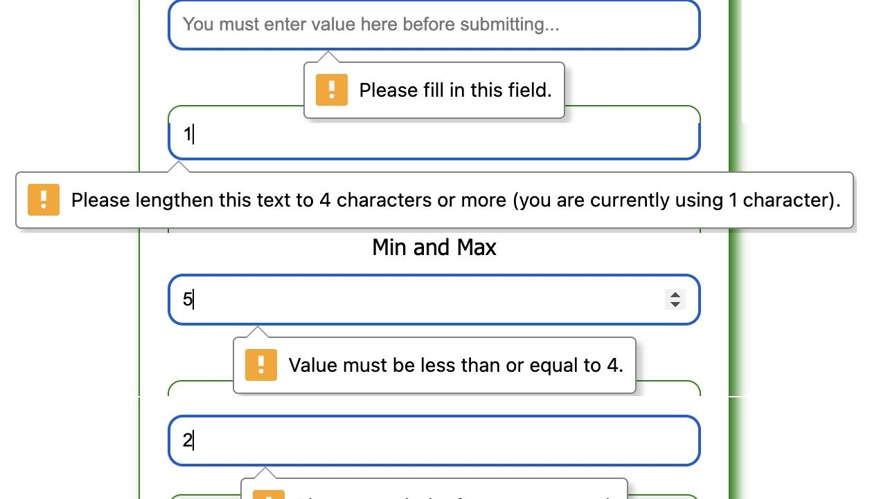
Attribute | Result
placeholder | Hint text
required | Required field
maxlength | Character limit
readonly | Read-only
disabled | Disabled input
multiple | Multiple files
pattern | Regex validation
autofocus | Auto focus
formtarget | Open result target

⚠️ Important Notes

✅ Use name for backend form data
# Source: AI Source: Provided by: [Data Path: Persons Table -> ID Column: 1, Name_En Column: Motasem Essam] -> From: [ChatGPT] on [5/6/2026]
👉 Backend receives values using name

✅ Use id with <label>
# Source: AI Source: Provided by: [Data Path: Persons Table -> ID Column: 1, Name_En Column: Motasem Essam] -> From: [ChatGPT] on [5/6/2026]
👉 Better accessibility

✅ Use validation attributes
# Source: AI Source: Provided by: [Data Path: Persons Table -> ID Column: 1, Name_En Column: Motasem Essam] -> From: [ChatGPT] on [5/6/2026]
👉 Better user experience

❌ Client-side validation is NOT enough for security
# Source: AI Source: Provided by: [Data Path: Persons Table -> ID Column: 1, Name_En Column: Motasem Essam] -> From: [ChatGPT] on [5/6/2026]
👉 Always validate on server too

🚀 In short:
# Source: AI Source: Provided by: [Data Path: Persons Table -> ID Column: 1, Name_En Column: Motasem Essam] -> From: [ChatGPT] on [5/6/2026]
HTML input attributes control validation, behavior, appearance, submission settings, and user interaction for form elements.

⚠️ Important Notes

✅ Always use <label> with inputs
# Source: AI Source: Provided by: [Data Path: Persons Table -> ID Column: 1, Name_En Column: Motasem Essam] -> From: [ChatGPT] on [5/6/2026]
👉 Better accessibility

✅ Use meaningful input types
# Source: AI Source: Provided by: [Data Path: Persons Table -> ID Column: 1, Name_En Column: Motasem Essam] -> From: [ChatGPT] on [5/6/2026]
👉 Better validation and mobile support

✅ Group related fields with <fieldset>
# Source: AI Source: Provided by: [Data Path: Persons Table -> ID Column: 1, Name_En Column: Motasem Essam] -> From: [ChatGPT] on [5/6/2026]
👉 Better organization

❌ Never trust form data without server validation
# Source: AI Source: Provided by: [Data Path: Persons Table -> ID Column: 1, Name_En Column: Motasem Essam] -> From: [ChatGPT] on [5/6/2026]
👉 Security requirement

🚀 In short:
# Source: AI Source: Provided by: [Data Path: Persons Table -> ID Column: 1, Name_En Column: Motasem Essam] -> From: [ChatGPT] on [5/6/2026]
HTML form elements collect and organize user input using inputs, labels, buttons, dropdowns, textareas, and grouped controls.

